AIU SMART CAMPUS
Energy Impact & Benchmark Analysis
How much energy could an integrated cyber-physical control platform realistically save at Alamein International University, New Alamein — based on comparable university implementations and AIU's actual campus scale?
How to read this report
Every number is tagged by origin: ACADEMIC EVIDENCE (published results), OFFICIAL AIU DATA (contract / university documents), ENGINEERING ESTIMATE (our modelling), or PROJECT TARGET. Anything that could not be verified is marked Not publicly verified.
The AIU figures are a benchmark-based estimated baseline and scenario projections — not measured AIU consumption and not a promise of savings. They must be validated against AIU's own meter data (Section 13).

Graduation project — Cyber-Physical Smart Building Control System
Prepared October 2026

Contents
Executive summary
1. Problem and approach
2. The Korean university experimental study
3. Comparable university implementations
4. Classrooms versus laboratories
5. AIU campus scale
6. Estimated AIU baseline energy
7. Scenario model
8. AIU savings results (energy, EGP, CO₂)
9. Building-category estimate
10. Mapping the evidence to our system
11. Why the project is valid, and the research gap
12. Assumptions and limitations
13. Final engineering conclusion
14. Source register
Appendix A. Benchmark data sheet

Executive summary
Universities have already demonstrated measurable energy savings through occupancy sensing and automated control. The question for AIU is how much of that opportunity an integrated platform can capture, and how confidently that can be said before AIU's own meters are analysed.
Headline findings
Evidence exists. A peer-reviewed field study at H University (Seoul, South Korea) measured 77.6% (parking lighting), 32.4% (classroom lighting), 27.9% (classroom cooling) and 28.2% (dormitory) savings with motion sensors and a card-key room-management system. Programme-level and building-level savings reported by U.S. universities range from 9% to 61%, but each number has a different scope.
Demonstrated range is wide, and scope matters. Savings of 9–20% come from campus/portfolio programmes and analytics; ~28–34% from end-use or building retrofits; 51–61% from laboratory ventilation redesign, which our system does not do.
AIU baseline (benchmark-based estimate, not measured): 263,020 m² of contractor-documented built-up area × 165 kWh/m²·yr ≈ 43.40 GWh/yr (range 22.62–93.96 GWh/yr across area and EUI sensitivities).
Controllable energy ≠ total energy. Our system acts on lighting, HVAC set-points/shutdown, non-critical plug loads and scheduled devices. We model 50–70% of campus electricity as controllable, and 50–90% of that as covered by the system.
Scenario results (annual): Conservative 1.08 GWh (2.5% of total); Moderate 3.28 GWh (7.6%); High-impact 7.66 GWh (17.6%).
Most defensible planning range for AIU: Conservative-to-Moderate — roughly 5–13% reduction in controllable energy, equal to about 2.5–7.6% of total campus electricity (1.08–3.28 GWh/yr; ≈ EGP 2.8–8.4 million/yr at EGP 2.55/kWh). The High-impact case is an upper bound that requires near-complete coverage and Korean-study-level results.

Honest limits. AIU's actual consumption, tariff category, current operating area and student numbers are not publicly verified. The 263,020 m² and 174,000 m² figures are contractor-stated BUA of construction packages — they are not the campus total and they are not the same thing (Section 5). The ≈150-acre campus area is stated in acres by the source we could access; it is a land area, not a built area.

1. Problem and approach
Campus buildings are occupied intermittently but are often conditioned and lit on fixed schedules. In hot climates, cooling dominates electricity use, so mismatches between occupancy and operation are costly. Published work shows that occupancy-driven control reduces this waste; what is rarely quantified is how that translates to a specific campus of a specific size.
This report therefore answers the question in three transparent steps, each reproducible from the model file delivered with the report:
- Extract measured results from the Korean field study and verified university benchmarks, labelling what each number represents.
- Establish AIU's scale from official and contractor documents, separating current, under-construction and planned areas.
- Apply a three-factor scenario model — controllable share × automation coverage × saving rate on controlled loads — to a benchmark-based baseline, and present ranges instead of a single figure.
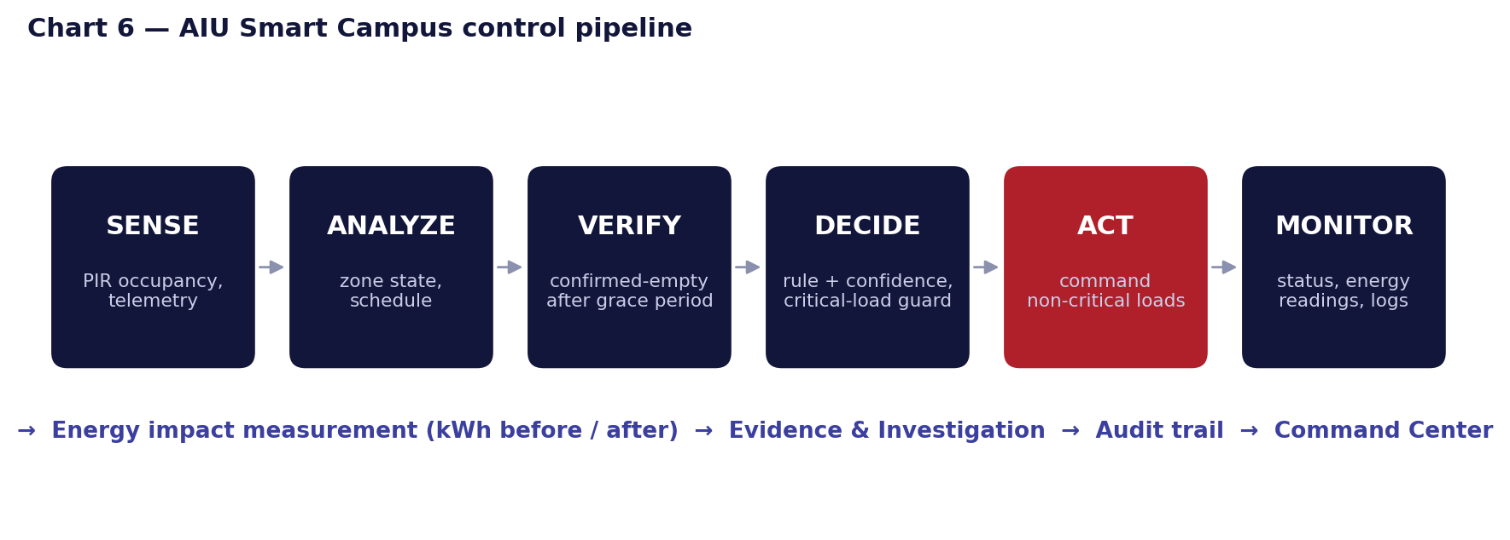
Chart 6 — AIU Smart Campus control pipeline (SENSE → ANALYZE → VERIFY → DECIDE → ACT → MONITOR)

2. The Korean university experimental study
Source and provenance
Lee, J.-W. & Kim, Y. I. (2020). *Energy Saving of a University Building Using a Motion Detection Sensor and Room Management System.* Sustainability 12(22), 9471. Seoul National University of Science and Technology. This is a South Korean study at a Seoul campus ("H University"), not an American study. The paper cites U.S. universities (e.g. Boston University, via Abidin et al.) only in its literature review, as institutions that had adopted occupancy sensors.

The authors measured electricity with and without sensors during normal operation rather than relying on simulation. Test objects: the Cyber Building (16,476 m², 27 classrooms and 35 labs, B2–8F, completed Aug 2013) and a female dormitory (5,994.53 m², 195 rooms, completed Mar 2019).
Experiment | Set-up and duration | Result (sensor OFF → ON) | Saving
1. Underground parking lot (B1 passageway) | 918.66 m², 51 lights (2.22 W/m²); RF/Doppler sensors dim to 20% and raise to 100% on detection; ~6 weeks, May–June; three on/off tests | 50.9 → 11.4 Wh/m²·day (saved 39.5) | 77.6% (tests: 77.7 / 79.3 / 75.7)
2a. Lecture rooms – lighting | 3 classrooms, 27 × 42 W LED; RF motion sensors switched on/off on alternate weeks, 4 weeks (26 May–22 Jun); outdoor temp 22.2–23.8 °C | 77.14 → 52.12 Wh/m²·day (saved 25.0) | 32.4% (two tests: 37.9 / 27.8)
2b. Lecture rooms – cooling (EHP) | 3 EHP units, 11 kW rated cooling; same weeks | 197.11 → 142.06 Wh/m²·day (saved 55.0) | 27.9% (two tests: 33.3 / 23.5)
3. Dormitory (key-card room-management system, RMS) | 10 test rooms vs 120 reference rooms (random from 195); 4 weeks baseline with RMS on, then 3 weeks with RMS off in test rooms; reference-group correction, Oct–Nov | Weekly per room: 68.83 kWh (RMS off) vs 49.45 kWh corrected (RMS on); saved 19.38 kWh/week (142.4 Wh/m²·day) | 28.2% (weekly: 40.0 / 16.2 / 30.9)

What these numbers do and do not mean
- Application-specific, not campus-wide. 77.6% applies to parking-lot lighting only (an all-night, low-occupancy space with dimmable fixtures). It must not be extrapolated to classrooms or to total campus energy.
- Short experiments. Four to seven weeks per object, at one campus, in shoulder-season weather (May–June, Oct–Nov). Classroom results rest on two on/off pairs and the authors note that class operation, weather and occupancy could not be held identical week to week.
- Dormitory saving is a calibrated estimate. It is the avoided increase when the RMS was switched off (test rooms used 32.3% more than the reference group, with 10 rooms and large room-to-room variance). The RMS is key-card-based presence logic, not a PIR motion sensor.
- Per-area figures are daily, in Wh/m²·day, during the measured weeks; the paper does not provide annualised campus totals, and neither do we.
- The paper's own literature review adds context: occupancy sensor + smart plug ≈34% (Jeong & Seo); daylight + occupancy lighting up to 65.2% (Hong et al.); classroom lighting PIR 10% (Nam et al.); campus platform 15–30% (Kolokotsa et al.).

3. Comparable university implementations
Each row states what the saving actually measures. Do not average these numbers: they mix lighting-only, HVAC-only, whole-building, laboratory-specific and campus-programme results, and some are targets or estimates rather than measured outcomes.
University / project | Country | Scale | Technology | Application & scope | Saving | Energy / cost saved | Source
H University (Lee & Kim) | South Korea | Lecture bldg 16,476 m²; dorm 5,994.53 m²; parking 918.66 m² test area | RF/Doppler motion sensors; key-card RMS | END-USE, measured before/after: lighting, EHP cooling, dormitory | 77.6% (parking light); 32.4% (class light); 27.9% (class cooling); 28.2% (dorm) | 39.5 / 25.0 / 55.0 / 142.4 Wh/m²·day; cost not reported | S1
Michigan State Univ. — Anthony Hall | USA | 1 building, 317,200 sq ft (≈29,470 m²) | Airflow monitoring, economizer repair, VFDs, demand ventilation, heat recovery, lighting controls | BUILDING-LEVEL multi-measure retrofit (partner-reported) | 34% (source EUI) | $536,000/yr; kWh not stated | S2
UC Irvine — Smart Labs | USA | 10 retrofitted labs; Natural Sciences II >100,000 sq ft | Variable ventilation + air-quality + occupancy sensors + digital controls | LABORATORY-specific; NS-II figure excludes lab process loads | 61% avg (10 labs); 60% headline; 51% NS-II | NS-II $180,000/yr | S3–S5
Pace University | USA | Portfolio 1–5 million sq ft | BMS scheduling, set-point policy, occupancy-matched HVAC, 2 energy specialists | CAMPUS-WIDE management programme (not a sensor product) | ≈18% avg annual (secondary); GHG −24% | 26M kWh + ~1M therms; $6.8M (thru Oct 2022) | S6, S7
Colorado Mesa University | USA | 16 buildings, 1.2 million sq ft | District geothermal heat pumps (450 boreholes) | HVAC PLANT technology — not sensing/automation | ≈ half of conventional HVAC energy (DOE) | 14.86M kWh/yr; $1.5M/yr; 10 kWh/sq ft·yr | S8
Univ. of Utah — Eyring buildings | USA | 5 buildings, 370,000 sq ft | CAV→VAV + sensors/controls | LAB/CLASSROOM retrofit — ESTIMATED | 44% EUI (est.) | $456,000/yr (est.) | S9
Carnegie Mellon Univ. (DOE BENEFIT) | USA | Research buildings | Depth-sensing occupancy + model-predictive control | Research TARGET — not a result | 20% target | — | S10
LBNL Smart Energy Analytics Campaign | USA (portfolio) | 104 orgs; 6,500 bldgs; >0.5 bn sq ft | Fault detection & diagnostics; energy information systems | PORTFOLIO medians (office + higher-ed = 80%) | 9% (FDD); 3% (EIS) median | — | S12
ACEEE smart-buildings review | USA (model) | Typical 100,000 sq ft education; 70,000 sq ft lab | Occupancy sensors + web lighting control; lab air-quality + occupancy + real-time ventilation | TECHNOLOGY-REVIEW model values | 11% (education); 40% (lab) | 20,900 and 390,000 kWh/yr per model building | S11
Technical Univ. of Crete (via S1) | Greece | Campus platform (CAMP-IT) | Web-based campus energy-management / control | CAMPUS platform (reported in S1's review) | 15–30% (as cited) | — | S13

Scope taxonomy used in this report
Lighting-only / end-use: Korean parking and classroom lighting. HVAC-only: Korean classroom EHP cooling. Building-level: MSU Anthony Hall, Utah. Laboratory-specific: UC Irvine, ACEEE lab. Campus-/portfolio-level programme: Pace, LBNL, Crete. Different mechanism (excluded from rate selection): Colorado Mesa geothermal. Target / estimate (not measured): CMU, Utah.
Observation: the more narrowly an end-use is controlled (lighting in a low-occupancy space), the higher the saving; the more broadly the metric is defined (whole campus or portfolio), the lower and more stable it becomes (≈9–20%).

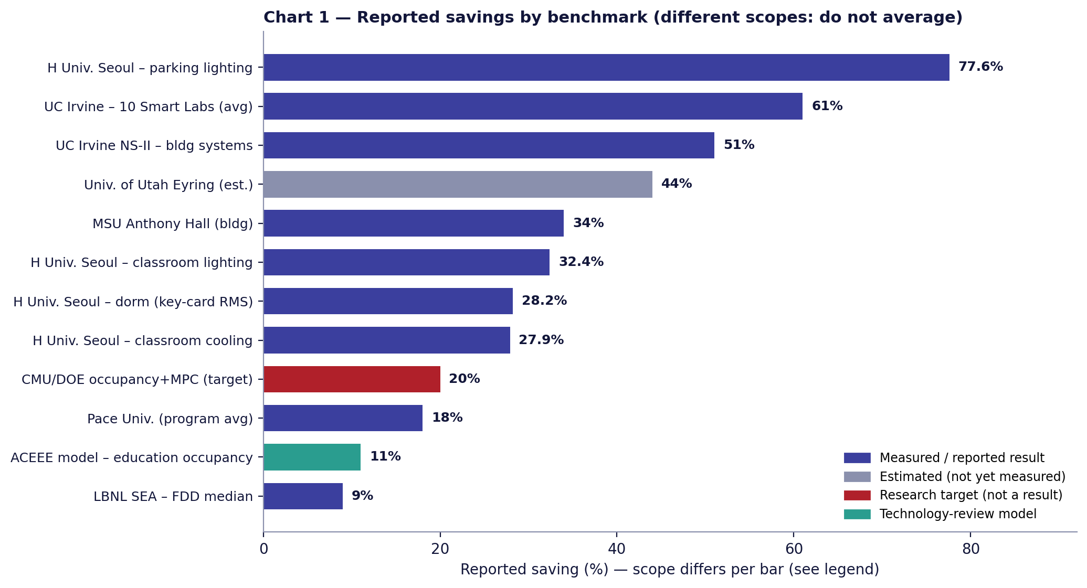
Chart 1 — Reported savings by benchmark (scopes differ; bars must not be averaged)

4. Classrooms versus laboratories
Laboratories behave very differently from classrooms, and Smart Lab 301 is the scenario our project demonstrates, so the two must be modelled separately.
 | General classrooms / lecture rooms | Laboratories
Dominant load | Lighting and cooling driven by occupancy hours | Ventilation (often 100% outside air), exhaust, fume hoods and process equipment, frequently critical
What occupancy control can do | Switch/setback lights and HVAC in confirmed-empty rooms. Korea: 32.4% lighting, 27.9% cooling in 3 classrooms | Reduce non-critical loads (lights, projector, charging, comfort AC). Deep savings require ventilation redesign
Demonstrated savings | 27.9–32.4% end-use (S1); 11% education model (S11) | UC Irvine 61% avg / 51% NS-II (S3, S4); ACEEE lab 40% (S11) — achieved by variable air-change-rate control with air-quality and occupancy sensors
Does AIU Smart Campus do this? | Yes — occupancy-confirmed shutdown of non-critical loads under rules | Partly. It shuts down non-critical loads and guards CRITICAL devices; it does not control fume-hood or air-change rates
Planning rate used here | Cons 10% / Mod 18% / High 28% on controlled loads | Cons 5% / Mod 10% / High 20% on a smaller controllable share (40%)

UC Irvine's result is real but comes from reducing laboratory air changes (from roughly one every 5–8 minutes, 24/7, to 2 per hour unoccupied and 4 per hour occupied, per UCI News) using air-quality and occupancy sensing. We therefore treat 51–61% as evidence that occupancy-aware laboratory ventilation control is powerful — not as a rate our current non-critical-load automation can claim. If AIU later integrates HVAC/ventilation control for labs, the laboratory rows of the model can be revisited.

5. AIU campus scale
Alamein International University is a national non-profit university in New Alamein City, Matrouh Governorate (inaugurated 2020, presidential decree 435 of 2020). The sources below give three different numbers that are easy to conflate; they refer to different things.
Item | Value | What it actually is | Status | Source
Campus land area | ≈150 acres (reported); user-cited '≈150 feddan' | Land area. The sources we accessed say acres; 1 feddan ≈ 4,200 m² (≈1.04 acre), so 150 acres ≈ 60.7 ha and 150 feddans ≈ 63 ha. Unit to be confirmed with AIU | Not publicly verified (unit) | A1
BUA 263,020 m² | 263,020 m² | Built-up area of REDCON's contract scope: construction & finishes (Arch & MEP) of 4 educational + 2 housing buildings. Listed 'on-going' on REDCON's site (page © 2023) | Contractor-stated; operational share not verified | A3
BUA 174,000 m² | 174,000 m² | BUA of SIAC's package ('first stage of the second sector'): Faculty of Arts & Design, Central Library, Student Services, Postgraduate, Administration, Conference Hall, Services + basement | Contractor-stated; one package | A2
BUA 100,390 m² | 100,390 m² | REC Consultants gives this for the same building list as SIAC. Conflicts with 174,000 m² — unreconciled | Discrepancy | A4
Phases | 3 phases | Redcon phase 1; SIAC phase 2; planned phase 3 = 3 buildings + a major hospital (2018 report) | Phase 3 not quantified | A5
Facilities listed | 10 faculty buildings; 4 accommodation towers; central library; administration; university + dentistry hospitals; sports/entertainment area; outdoor theatre; 9 residential buildings outside the campus | Programme description of the campus | Reported (secondary) | A1
Current students | — | — | Not publicly verified | —
Planned capacity | ≈15,000 students at full build-out | Master-plan designer statement (30-year plan) | PLANNED | A6

Current / under construction / planned
- CURRENT (operating): AIU is open and teaching (faculties launched 2020–2024 per its public profile). The operating built-up area is not publicly verified; the contract packages above overlap the operating buildings but cannot be proven to equal them.
- UNDER CONSTRUCTION: REDCON lists its project as 'on-going'; the planned third phase (three buildings + hospital) is not quantified.
- PLANNED / MASTER PLAN: full build-out for ≈15,000 students; ≈150-acre land. These are never used as built-up area in the model.
Modelling decision
We use 263,020 m² (the larger single contractor-documented BUA) as the central reference area, with 174,000 m² as a lower sensitivity and 437,020 m² (263,020 + 174,000, assuming the two packages are additive — unverified) as an upper sensitivity. The first two are never added together in the central case. Replace with AIU's real metered/operational area as soon as it is available.

6. Estimated AIU baseline energy (Method A — energy-use intensity)
Annual energy = built-up area × EUI. Conversion: 1 GWh = 1,000 MWh = 1,000,000 kWh. This is a benchmark-based estimated baseline, not actual AIU consumption.

EUI selection (electricity, hot-climate educational buildings)
Case | EUI (kWh/m²·yr) | Anchors (from S14 unless noted) | Confidence
Low | 130 | Roraima Univ. (Brazil, CDD≈3,316) administrative 132; Al-Rajhi 145–155 would be above this | MEDIUM
Mid (central) | 165 | University of Sharjah ≈165; Dammam 167–217; Al-Rajhi (Saudi) 145–155 | MEDIUM
High | 215 | Dammam upper bound 217; US college median ≈266 kWh/m² incl. heating fuels (S15) is a cross-check | LOW–MEDIUM

BUA case | Low 130 | Mid 165 | High 215
174,000 m² (SIAC package) | 22,620,000 kWh = 22.62 GWh | 28,710,000 kWh = 28.71 GWh | 37,410,000 kWh = 37.41 GWh
263,020 m² (REDCON; central) | 34,192,600 kWh = 34.19 GWh | 43,398,300 kWh = 43,398 MWh = 43.40 GWh | 56,549,300 kWh = 56.55 GWh
437,020 m² (sum, unverified) | 56,812,600 kWh = 56.81 GWh | 72,108,300 kWh = 72.11 GWh | 93,959,300 kWh = 93.96 GWh

The central baseline of 43.4 GWh/yr is an order-of-magnitude planning figure. AIU's real consumption may differ materially (hospital loads, central plant, partial occupancy, New Alamein's Mediterranean coastal climate versus Gulf climates).

7. Scenario model
Rather than one number, three scenarios combine three factors. Annual saved = Baseline × Controllable share × Automation coverage × Saving rate on controlled loads.
Factor | Conservative | Moderate | High-impact | Evidence / reasoning | Confidence
Controllable share of total electricity | 50% | 60% | 70% | Lighting, HVAC and plug loads that follow occupancy/schedule; excludes lifts, pumps, labs' critical loads, IT, hospital equipment. Cooling ≈70% of electricity in hot-climate campuses (search extract) supports a majority share | LOW
Automation coverage (share of controllable load actually under the system) | 50% | 70% | 90% | A deployment/design target, not evidence. Depends on sensor, actuator and metering rollout | LOW (target)
Saving rate on controlled loads | 10% | 18% | 28% | 10%: LBNL median 9% (FDD), ACEEE education 11%. 18%: Pace ≈18%, CMU/DOE target 20%, Crete >20%. 28%: Korea measured 27.9% (cooling) – 32.4% (lighting) and dorm 28.2% | MEDIUM

Why not 30% (or more)?
- 30%+ end-use savings were measured for specific end-uses over weeks (S1) or in whole-building retrofits including HVAC plant/controls changes (S2: 34%), and 51–61% for lab ventilation redesign. None is a sustained campus-wide result from non-critical-load automation.
- Campus-/portfolio-level evidence clusters at ≈9–20% (S6, S12, S13). The High-impact case therefore applies 28% only to controlled loads and only with 90% coverage.
- Most defensible range for AIU: Conservative to Moderate, i.e. ≈5–13% of controllable energy (≈2.5–7.6% of total). High-impact is a stretch target contingent on real baseline data.

8. AIU savings results
Reference case: 263,020 m² × 165 kWh/m²·yr = 43,398,300 kWh/yr. Five-year values assume flat annual savings from first full year (no ramp-up, degradation, area growth or tariff escalation).
 | Conservative | Moderate | High-impact
Controllable energy (kWh/yr) | 21,699,150 | 26,038,980 | 30,378,810
Under system control (kWh/yr) | 10,849,575 | 18,227,286 | 27,340,929
Saving rate on controlled loads | 10% | 18% | 28%
Annual energy saved (kWh) | 1,084,958 | 3,280,911 | 7,655,460
Annual energy saved (MWh / GWh) | 1,085 MWh / 1.08 GWh | 3,281 MWh / 3.28 GWh | 7,655 MWh / 7.66 GWh
Monthly energy saved (kWh) | 90,413 | 273,409 | 637,955
5-year energy saved (kWh) | 5,424,788 | 16,404,557 | 38,277,301
% of total campus electricity | 2.5% | 7.6% | 17.6%
% of controllable energy | 5.0% | 12.6% | 25.2%
Projected annual consumption (GWh) | 42.31 | 40.12 | 35.74

Financial impact (tariff scenario)
Tariff: EGP 2.55/kWh — EgyptERA official schedule from April 2026, medium-voltage (22–11 kV) 'other users', excluding the 3 Pt/kWh consumption stamp and service fees. A campus of this size would plausibly be medium-voltage, but AIU's billing category is not publicly verified; at low-voltage EGP 2.74/kWh values rise ≈7%. Constant tariff, no escalation.
 | Conservative | Moderate | High-impact
Annual saving (EGP million) @2.55 | 2.8 | 8.4 | 19.5
5-year saving (EGP million) @2.55 | 13.8 | 41.8 | 97.6
Annual saving (EGP million) @2.74 (LV) | 3.0 | 9.0 | 21.0

CO₂ impact (indicative)
Using Egypt's grid intensity of 0.563 kgCO₂/kWh (Ember data, lifecycle basis; obtained through a secondary data aggregator — re-confirm on ember-energy.org before formal citation; confidence MEDIUM):
 | Conservative | Moderate | High-impact
Annual CO₂ avoided (tCO₂) | 611 | 1,847 | 4,310
5-year CO₂ avoided (tCO₂) | 3,054 | 9,236 | 21,550

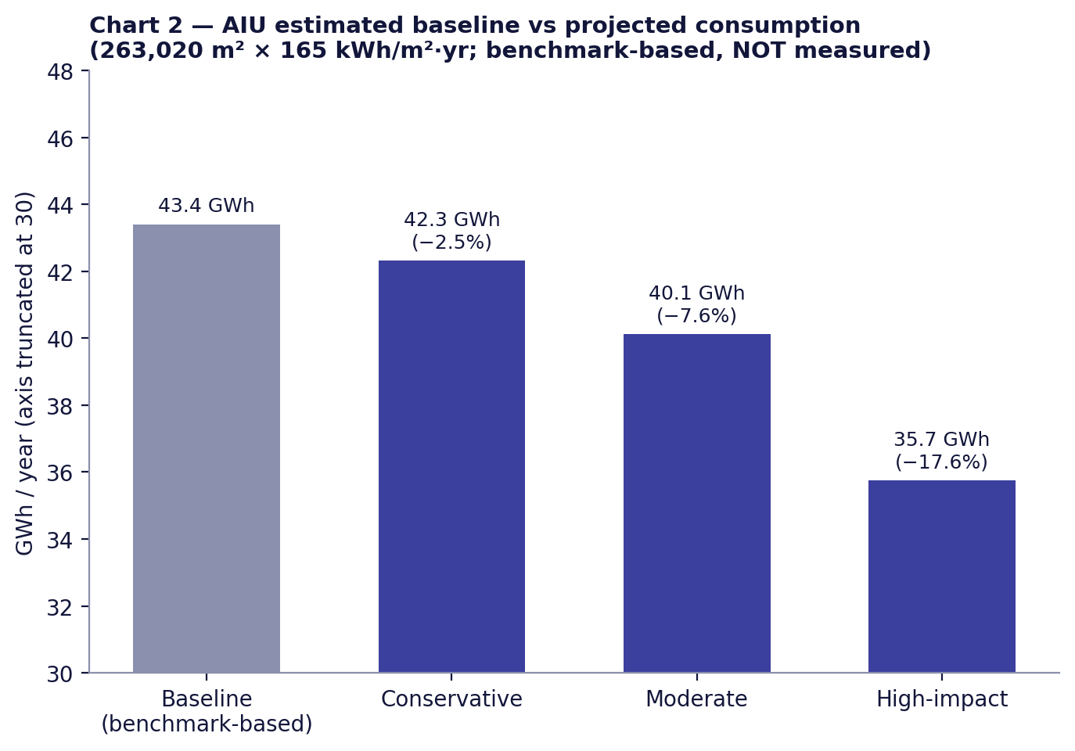
Chart 2 — Baseline vs projected consumption (benchmark-based baseline; axis truncated)
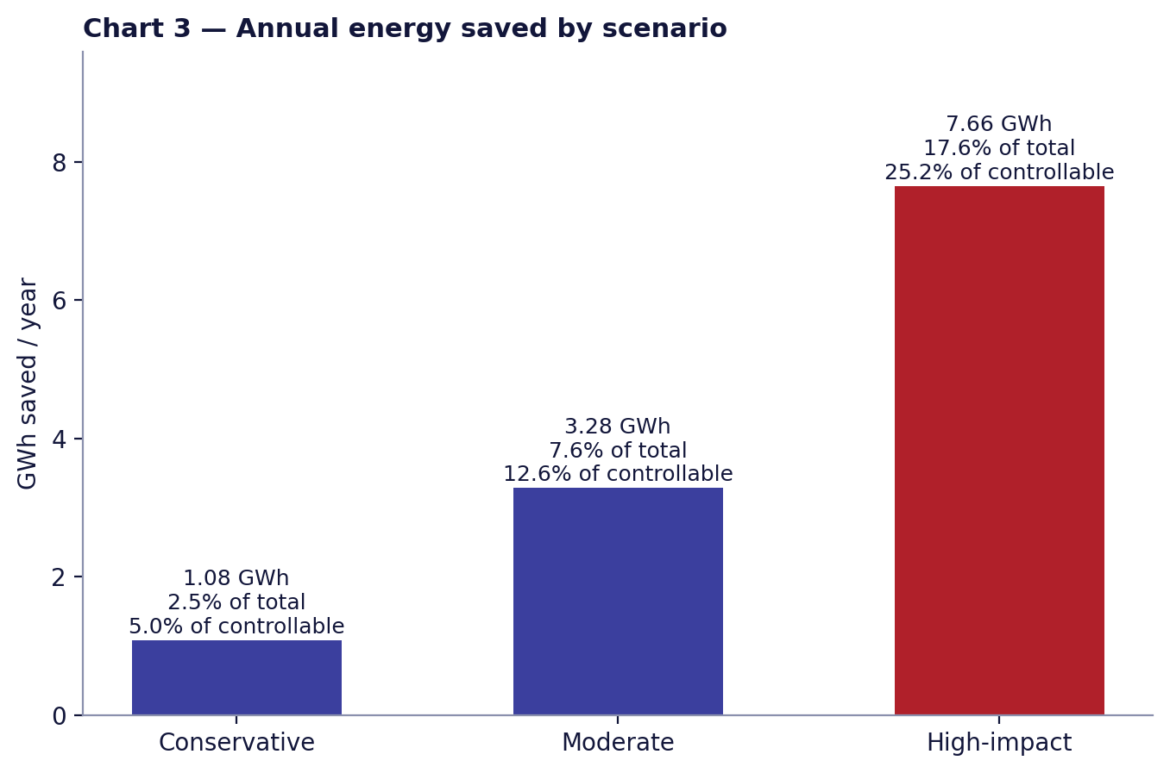
Chart 3 — Annual energy saved by scenario
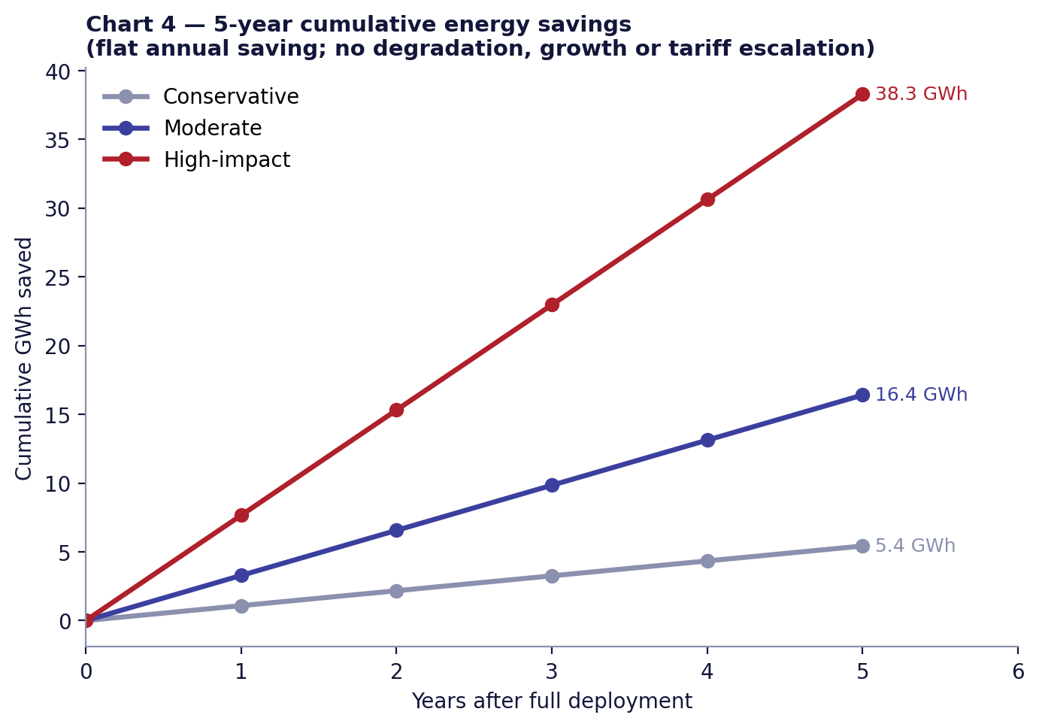
Chart 4 — Five-year cumulative energy saved

Sensitivity: annual savings (MWh) across area and EUI
Area case | EUI 130 | EUI 165 | EUI 215
174,000 m² | 566 / 1,710 / 3,990 | 718 / 2,170 / 5,064 | 935 / 2,828 / 6,599
263,020 m² (central) | 855 / 2,585 / 6,032 | 1,085 / 3,281 / 7,655 | 1,414 / 4,275 / 9,975
437,020 m² | 1,420 / 4,295 / 10,022 | 1,803 / 5,451 / 12,720 | 2,349 / 7,103 / 16,574
Cells show Conservative / Moderate / High-impact annual savings in MWh. The full range across the sensitivity grid is roughly 0.6 to 16.6 GWh/yr, dominated by area and EUI uncertainty — which is why validation with AIU meter data is the first priority.

9. Building-category estimate
AIU has not published a building-category area breakdown, so shares below are a clearly labelled scenario assumption (LOW confidence) applied to the central 263,020 m². Category EUI is held equal (165) to avoid inventing category intensities; categories differ only in controllable share and saving rate (Section 4, Korean results, ACEEE). Hospital and sports facilities are grouped as 'other' with low coverage.
Category | Assumed area share | Baseline (MWh) | Controllable | Control strategy | Saved MWh/yr (C / M / H)
Academic / classrooms | 40% (105,208 m²) | 17,359 | 65% | Occupancy-confirmed lighting/HVAC/plug shutdown | 564 / 1,422 / 2,843
Laboratories (teaching) | 10% (26,302 m²) | 4,340 | 40% | Non-critical loads only; critical ventilation guarded | 43 / 122 / 312
Admin / library / services | 15% (39,453 m²) | 6,510 | 65% | Schedules + occupancy; plug loads | 169 / 444 / 876
Dormitories / housing | 25% (65,755 m²) | 10,850 | 60% | Presence-based room shutdown (cf. Korean RMS) | 325 / 820 / 1,640
Sports / hospital / other | 10% (26,302 m²) | 4,340 | 40% | Schedules; limited scope | 43 / 122 / 234

Bottom-up cross-check: summing categories gives 1,146 / 2,929 / 5,907 MWh/yr (2.6% / 6.7% / 13.6% of total), against the top-down 1,085 / 3,281 / 7,655 MWh. The two approaches agree within about 6%, 11% and 23% (Conservative, Moderate, High-impact), which supports the planning range but does not validate it. Academic buildings and dormitories carry the greatest potential because they combine large area, occupancy-driven loads and the strongest published evidence; laboratories contribute little under non-critical-load control.
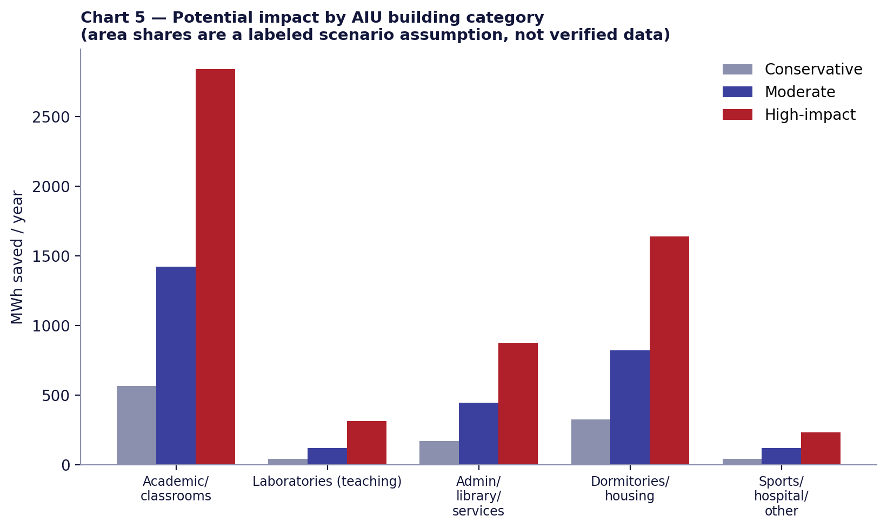
Chart 5 — Potential impact by building category (area shares are assumptions)

10. Mapping the evidence to our system
AIU Smart Campus implements the cycle SENSE → ANALYZE → VERIFY → DECIDE → ACT → MONITOR on top of Smart Building, Zones, Sensors, Devices, Automation Rules and Logs, Energy Readings, Access Control, Evidence, Investigation, auditability and a Command Center.
Stage | What our system does | Evidence it relates to
SENSE | PIR occupancy sensing and telemetry feed zone state | Korean sensors (S1); occupancy sensing in S10–S11
ANALYZE | Combines occupancy with the zone schedule (open/closed) and device state | Schedule-aware control; campus platforms (S13)
VERIFY | Confirms a zone is empty for a grace period before acting; avoids shutting down occupied rooms | Addresses false-trigger risk noted in occupancy literature; Korean study had no verification layer
DECIDE | Deterministic rule + confidence; CRITICAL-device protection; fail-safe | Rule-based (not AI/ML)
ACT | Issues commands to non-critical loads; command outcome tracked (success / failed / queued) | End-use control (S1 lighting, EHP)
MONITOR | Energy readings, automation log, honest failure states | Needed for measured, not assumed, savings

Why the architecture can improve on simple occupancy ON/OFF
- Verification before action reduces nuisance shutdowns, which is the main reason occupancy control gets disabled by users in practice.
- Context (schedule, zone type, critical-load guard) lets the same sensor drive different, safer actions in classrooms, labs and dormitories.
- Energy readings + automation logs turn savings from an assumption into a measurable before/after quantity — the validation gap in most published results.
- Security, evidence and investigation are not energy features, but they make automated physical actions auditable, which matters for adoption on a real campus.
What the prototype does not yet prove
Our demonstration environment is a software + bench prototype. The current system has not measured kWh savings at AIU, has not been deployed campus-wide, and its device commands in the demo environment may report states such as `queued_no_broker` or `COMMAND_FAILED` when no physical broker/hardware responds — we present those honestly. The savings in this report are therefore projections from external evidence.

11. Why the project is valid, and the research gap
This project does not claim that smart campuses are a new idea. Existing research shows that occupancy sensing, lighting automation, HVAC automation and room management work, and that university buildings achieve measurable savings (S1–S13).
Our contribution is integration: physical sensing + context + verification + automation decision + physical control + energy measurement + security + evidence + investigation + auditability in one cyber-physical campus control platform.

The gap, stated carefully
Published implementations typically concentrate on one or two of lighting, HVAC, occupancy detection, energy monitoring, individual buildings or laboratory optimisation. We did not find, in the sources reviewed, an openly documented university implementation that also ties energy automation to access control, evidence, investigation and a unified command centre — but this is a statement about the sources we reviewed, not a claim that no such system exists.
Typical focus in reviewed work | AIU Smart Campus adds
Lighting or HVAC control in one building type | Zone-level automation across rooms/labs with critical-load guard
Energy monitoring dashboards | Closed loop: decision → command → status → energy impact
Occupancy detection accuracy | Verification step and decision logging before action
Energy only | Energy + access control + evidence + investigation + auditability in one Command Center

12. Assumptions and limitations
Value | Source | Why used | Confidence
Reference BUA 263,020 m² | A3 REDCON (contractor) | Largest single documented BUA; not verified as operational campus total | MEDIUM (as a documented number) / LOW (as campus total)
Sensitivity BUA 174,000 / 437,020 m² | A2 SIAC; A2+A3 sum | Lower bound and unverified additive upper bound | LOW
EUI 130 / 165 / 215 kWh/m²·yr | S14 (hot-climate universities) | Electricity-dominant cooling climate analogues; New Alamein climate differs | MEDIUM
Controllable share 50 / 60 / 70% | Engineering estimate | Excludes critical, process and fixed loads | LOW
Automation coverage 50 / 70 / 90% | Project target | Design variable of deployment, not evidence | LOW
Saving on controlled loads 10 / 18 / 28% | S1, S6, S10–S13 | Spans campus-level evidence to measured end-use maxima | MEDIUM
Category area shares 40/10/15/25/10% | Engineering estimate | AIU category areas not published | LOW
Lab controllable 40%, rates 5/10/20% | S3–S4, S11 + system scope | Our system does not control lab ventilation | LOW
Tariff EGP 2.55/kWh (2.74 LV) | E1 EgyptERA Apr 2026 | Official; AIU category unknown; excludes stamp and fees | MEDIUM
Flat 5-year saving, no escalation | Engineering simplification | Avoids speculative growth, ramp-up or tariff changes | MEDIUM
CO₂ factor 0.563 kg/kWh | E2 Ember (secondary access) | Egypt-specific grid intensity; lifecycle basis | MEDIUM
Operating hours/semester pattern | — | Not modelled; Korean results come from semester weeks | LOW

Other limitations: published savings are partly weather- and occupancy-dependent; savings from different end-uses are not additive; rebound and behaviour effects are not modelled; capital and maintenance costs are not included (so no payback is claimed); and none of the benchmarks is from Egypt.

13. Final engineering conclusion
- Is there evidence this type of system saves energy in universities? Yes. A field study with before/after measurements (Seoul) and multiple U.S. programmes show measurable savings from occupancy-based control and automation.
- What range has actually been demonstrated? 27.9–32.4% on specific classroom end-uses and 28.2% in dormitories (Korea); 9–20% at campus/portfolio level (LBNL, Pace); 34% building-level retrofit (MSU); 51–61% in laboratories through ventilation redesign.
- Defensible target range for AIU? About 5–13% reduction in controllable energy (Conservative to Moderate), equal to 2.5–7.6% of total campus electricity, subject to validation through actual baseline measurements. 25% of controllable energy (High-impact) is an upper bound, not a plan.
- How much energy is that? On the benchmark-based baseline of 43.40 GWh/yr: 1.08–3.28 GWh/yr (5,425–16,405 MWh over five years), ≈ EGP 2.8–8.4 million per year and ≈ 611–1,847 tCO₂ per year (indicative). High-impact: 7.66 GWh/yr.
- Which AIU building types have the greatest potential? Academic/classroom buildings and dormitories, followed by administration/library; laboratories offer less under non-critical-load control; hospital and central plant are largely out of scope.
- What measurements prove the actual AIU savings? (a) 12 months of utility-meter and sub-meter data to establish the real baseline and the controllable share; (b) AIU's actual tariff category and bills; (c) per-zone energy readings (lighting, AC, plug) with timestamps; (d) occupancy hours by zone; (e) outdoor temperature/degree-days for normalisation; (f) automation-log events linked to measured load drops.
- How to validate experimentally? Replicate the Korean design where it was strongest: alternate-week ON/OFF in matched zones (e.g. Smart Lab 301 and a comparable room), a reference group of untreated rooms with calibration (Eq. 1 of S1), logging at ≥15-minute resolution, ≥4–8 weeks per season, weather normalisation, and reporting results with confidence intervals. Pilot first in one classroom block and one dormitory floor, then extend.
Defensible one-sentence claim
Based on comparable university implementations, AIU could potentially target an estimated 5–13% reduction in controllable energy consumption (≈2.5–7.6% of total campus electricity), with a higher-bound scenario of ≈25% of controllable energy, subject to validation through actual baseline measurements.

14. Source register
Sources are separated by evidence type. Items that were obtained through secondary extracts, or that we could not independently reopen, are flagged in the last column text.

A. ACADEMIC & OFFICIAL BENCHMARK EVIDENCE
ID | Title | Institution / author | Year | URL | Number extracted | What it represents
S1 | Energy Saving of a University Building Using a Motion Detection Sensor and Room Management System | J.-W. Lee & Y. I. Kim, Seoul Nat. Univ. of Science & Technology — Sustainability 12(22):9471 | 2020 | https://doi.org/10.3390/su12229471 | 77.6% / 32.4% / 27.9% / 28.2%; 918.66 m² parking, 3 classrooms, 10 dorm rooms vs 120 reference | Measured before/after savings at H University, Seoul (South Korea): parking lighting, classroom lighting, classroom cooling (EHP), dorm (key-card RMS)
S2 | Michigan State University: Anthony Hall (Better Buildings Solution Center) | MSU via U.S. DOE Better Buildings (partner-reported; 'not the viewpoint of DOE') | 2015 | https://betterbuildingssolutioncenter.energy.gov/showcase-projects/michigan-state-university-anthony-hall | 34% energy savings; $536,000/yr; >100,000 sq ft (317,200 sq ft per project summary) | Whole-building (source-EUI) saving after multi-measure controls/HVAC retrofit
S3 | UC Irvine: Smart Labs Initiative / Natural Sciences II (Better Buildings Solution Center) | UC Irvine via U.S. DOE Better Buildings | 2015 | https://betterbuildingssolutioncenter.energy.gov/showcase-projects/uc-irvine-smart-labs-initiativenatural-sciences-ii | 51% energy savings; $180,000/yr | Building-systems energy only (metered VFD + BMS-trend model); excludes lab process loads
S4 | Laboratory energy-savings program earns green leadership award (UCI News) | UC Irvine Strategic Communications | 2013 | https://news.uci.edu/2013/05/29/laboratory-energy-savings-program-earns-green-leadership-award/ | 61% average total energy saving across 10 retrofitted labs; up to 60%; air changes 2/h unoccupied vs 4/h occupied | Laboratory-specific savings from variable ventilation + air-quality + occupancy sensors
S5 | University of California Irvine Smart Labs Initiative Success Story | U.S. DOE Federal Energy Management Program | 2018 | https://www.energy.gov/cmei/femp/articles/university-california-irvine-smart-labs-initiative-success-story | 60% energy savings (headline) | Program headline; DOE video summary
S6 | Pace University: Coordinated Energy Management Strategy | Pace University via U.S. DOE Better Buildings | 2024 | https://betterbuildingssolutioncenter.energy.gov/implementation-models/pace-university-coordinated-energy-management-strategy | 26 million kWh + ~1 million therms and $6.8M saved (through Oct 2022); portfolio 1–5 million sq ft; 24% GHG reduction | Campus-wide program (energy specialists + BMS scheduling + set-point policy); NOT a sensor-hardware result
S7 | Pace University partner/poster summary (18% average annual energy reduction) | U.S. DOE Better Buildings (search extract of Summit materials) | 2023 | https://betterbuildingssolutioncenter.energy.gov/partners/pace-university | ~18% average annual energy reduction; 250 million kBtu; $7.2M | Campus-wide programme average. Secondary extract — re-confirm against the primary poster before citing
S8 | Geothermal Heat Pump Case Study: Colorado Mesa University | U.S. DOE (DOE/GO-102025-6426) | 2026 | https://www.energy.gov/hgeo/geothermal/articles/geothermal-heat-pump-case-study-colorado-mesa-university | 14.86 million kWh/yr saved; $1.5M/yr; 1.2 million sq ft; 16 buildings; 10 kWh/sq ft/yr | Campus district geothermal heat-pump system. A HVAC plant technology, NOT sensing/automation — excluded from the saving-rate range
S9 | Better Buildings: University of Utah — Eyring Chemistry & Biology buildings (blog) | U.S. DOE Better Buildings Beat Team | 2017 | https://betterbuildingssolutioncenter.energy.gov/beat-blog/specialized-savings-better-buildings-university-partner-showcases-big-savings-science | 44% EUI saving (estimated); $456,000/yr; 5 buildings, 370,000 sq ft | Estimated lab/classroom building retrofit (CAV→VAV + sensors/controls)
S10 | Human-in-the-Loop Sensing/Control for Commercial Building Energy Efficiency and Occupant Comfort | Carnegie Mellon University / U.S. DOE BENEFIT-2016 | 2017 | https://www.energy.gov/cmei/buildings/articles/human-loop-sensingcontrol-commercial-building-energy-efficiency-and | 20% energy saving TARGET (occupancy sensing + model-predictive control) | Research target, not a measured result
S11 | Smart Buildings: Using Smart Technology to Save Energy in Existing Buildings (Report A1701) | ACEEE | 2017 | https://www.aceee.org/sites/default/files/publications/researchreports/a1701.pdf | Education (occupancy sensors + web lighting control) 11%; laboratory (air-quality + occupancy sensors + real-time ventilation) 40%; integrated smart building 30–50% where otherwise inefficient | Technology-review model values synthesised from case studies — not a single measured campus
S12 | Smart Energy Analytics Campaign — outcomes | Lawrence Berkeley National Laboratory / U.S. DOE | 2019–2020 | https://www.energy.gov/cmei/buildings/articles/smart-energy-analytics-campaign-reveals-continued-energy-and-cost-savings | Median 9% (FDD) and 3% (EIS); 104 organisations, 6,500 buildings, >0.5 billion sq ft | Portfolio-wide median savings from analytics software (office + higher-education = 80% of participants)
S13 | Energy management of campus buildings (CAMP-IT), cited as ref. [12] in S1 | D. Kolokotsa et al., Technical University of Crete (Greece) — Energy and Buildings | 2009 (via S1) | https://doi.org/10.3390/su12229471 (S1 literature review) | 15–30% depending on period of year (as reported in S1); >20% efficiency per secondary search | Web-based campus energy-management platform. Taken from S1's literature review — original paper not independently opened
S14 | Benchmarking of Energy Consumption in Higher Education Buildings in Saudi Arabia: Sulaiman Al-Rajhi University Case (Table 2 compiles worldwide university EUIs) | Energies 16(3):1204 | 2023 | https://www.mdpi.com/1996-1073/16/3/1204 | Al-Rajhi 145–155 kWh/m²·yr; Sharjah ≈165; Dammam 167–217; Roraima admin 132 kWh/m²·yr | Measured/literature electricity EUIs of university buildings in hot climates
S15 | U.S. National Median EUI by Property Type (ENERGY STAR Portfolio Manager) | U.S. EPA / ENERGY STAR (CBECS-based) | 2024 | https://portfoliomanager.energystar.gov/pdf/reference/US%20National%20Median%20Table.pdf | College/University site EUI 84.3 kBtu/ft² (≈266 kWh/m², all fuels) | US median incl. heating fuels — used as an upper cross-check only; not climate-matched to Egypt

B. OFFICIAL AIU / CONTRACT DATA
ID | Title | Institution / author | Year | URL | Number extracted | What it represents
A1 | Alamein International University (encyclopaedic summary of AIU's own site) | Wikipedia citing aiu.edu.eg (archive 2023) | 2025 | https://en.wikipedia.org/wiki/Alamein_International_University | ~150 acres; central library; outdoor theatre; sports area; university hospital; dentistry hospital; administration building; 10 faculty buildings; 4 accommodation towers; 9 residential buildings outside campus | Describes the built/operating campus programme (area stated in ACRES in this source). Secondary — confirm on aiu.edu.eg
A2 | Alamein International University of Science and Technology — first stage of the second sector | SIAC Construction (contractor) | 2026 (page) | https://www.siac.com.eg/?q=experience-sectors%2Fbuilding%2Falamein-international-university-science-and-technology-first-stage | Total built-up area 174,000 m²; Faculty of Arts & Design, Central Library, Student Services, Postgraduate, Administration, Conference Hall, Services Building + basement | BUA of ONE contract package (phase/sector), not the whole campus
A3 | Alamein International University (project page) | REDCON Construction (contractor) | 2023 (page) | https://redconcon.com/project/alamein-university/ | BUA 263,020 m²; client NUCA; scope: construction & finishes (Arch & MEP) for 4 educational + 2 housing buildings; marked 'on-going' | BUA of REDCON's contract scope; not necessarily the total campus
A4 | Alamain International University of Science and Technology (project page) | REC Consultants (structural consultant) | 2026 (page) | https://rec-consultants.net/alamein-project | Total BUA 100,390 m² with the SAME building list as A2 (A2 says 174,000 m²) | Unreconciled discrepancy between two firms for the same package — shown as sensitivity, not resolved
A5 | Egypt to launch third work phase for New Alamein University in 2019 | Amwal Al Ghad | 2018 | https://en.amwalalghad.com/egypt-to-launch-third-work-phase-for-new-alamein-university-in-2019/ | 3 phases; Redcon = phase 1; SIAC = phase 2 (six administrative buildings + utilities); phase 3 = 3 buildings + a major hospital; New Alamein City 48,000 feddans | News report (2018) used to place contract packages in phases; planned 3rd phase is NOT quantified
A6 | Alamein University Master Plan | Architizer (designer listing) | n/d | https://architizer.com/projects/alamein-university-master-plan/ | Master plan for 30 years; full build-out for ≈15,000 students | PLANNED / master-plan student capacity (designer statement, not an enrolment figure)

C. ENGINEERING ESTIMATES (inputs from external sources)
ID | Title | Institution / author | Year | URL | Number extracted | What it represents
E1 | EgyptERA — Electricity Tariff Starting From April 2026 | Egyptian Electric Utility & Consumer Protection Regulatory Agency | 2026 | https://egyptera.org/en/TarrifApril2026.aspx | Medium voltage (22–11 kV) 'other users' 255 Pt/kWh; low voltage 274 Pt/kWh; commercial >1000 kWh 279 Pt/kWh; consumption stamp 3 Pt/kWh (non-residential) | Official tariff schedule (excl. service fees/stamp unless stated). AIU's actual billing category is not publicly verified
E2 | Egypt grid electricity intensity 0.563 kgCO₂/kWh | Ember (via GreenCalculus data table 'Ember 2025') | 2025 | https://greencalculus.com/data/grid-electricity-emission-factors/ | 0.563 kgCO₂/kWh (lifecycle basis) | Used for an indicative CO₂ estimate; accessed through a secondary aggregator — re-confirm on ember-energy.org

D. OUR PROJECT TARGET
Item | Value | Basis
Automation coverage | 50 / 70 / 90% of controllable load | Deployment target for the platform (not evidence)
Planning range | 5–13% of controllable energy (≈2.5–7.6% of total) | Conservative-to-Moderate scenarios derived above; to be validated
Stretch scenario | ≈25% of controllable energy (≈17.6% of total) | High-impact: Korean-level rates at 90% coverage

Appendix A. Benchmark data sheet
Fields requested for every benchmark. 'n/s' = not stated in the source we accessed; nothing has been filled in by assumption.
Benchmark | Building / campus | Area | # bldgs | Energy consumption | Occup. sensing | HVAC ctrl | Light ctrl | Energy monitoring | Automation | Saving % | Annual kWh saved | Annual cost saved | Method | Pub. date
H Univ. Seoul (S1) | Cyber Bldg; dorm; B1 parking | 16,476 m²; 5,994.53 m²; 918.66 m² test area | 2 + parking | Sensor-off: 50.9 (parking), 77.1 light / 197.1 cooling (class) Wh/m²·day; dorm ref. 25.3 kWh/wk | Yes (RF/Doppler; key-card RMS) | Yes (EHP) | Yes | Yes (metered experiments) | Sensor-triggered | 77.6 / 32.4 / 27.9 / 28.2 | n/s (39.5; 25.0; 55.0; 142.4 Wh/m²·day) | n/s | Measured ON/OFF alternate weeks; dorm reference-group calibration | 14 Nov 2020
MSU Anthony Hall (S2) | Anthony Hall, E. Lansing | 317,200 sq ft | 1 | n/s (EUI blank on page) | Partial (demand ventilation, lighting controls) | Yes | Yes | Airflow monitoring | Controls | 34% (source EUI) | n/s | $536,000 | Partner-reported | 22 Oct 2015
UC Irvine NS-II (S3) | Natural Sciences II | > 100,000 sq ft | 1 | n/s | Yes | Yes (ventilation) | Yes | Yes (VFD meters + BMS trends) | Yes | 51% | n/s | $180,000 | Metered VFD data + BMS-trend model; excludes lab process loads | 22 Oct 2015
UC Irvine program (S4,S5) | 10 retrofitted labs | n/s | 10 labs | n/s | Yes | Yes (air changes) | n/s | Yes | Yes | 61% avg; up to 60% (S4); 60% (S5) | n/s | n/s | University-reported average | 29 May 2013; 4 Oct 2018
Pace University (S6,S7) | NYC / Westchester portfolio | 1–5 million sq ft | n/s | n/s | Tag only | Yes (match HVAC to occupancy) | n/s | Yes (BMS sweeps, energy accounting) | Scheduling; no capex | ≈18% avg (secondary) | 26,000,000 kWh + ~1M therms (through Oct 2022) | $6.8M | Weather/size-normalised expected vs actual | 26 Mar 2024
Colorado Mesa (S8) | Grand Junction campus | 1.2 million sq ft | 16 | 10 kWh/sq ft·yr | No | Geothermal plant | No | n/s | No | ≈ half of conventional HVAC | 14,860,000 | $1.5M | DOE case study | May 2026
Univ. of Utah Eyring (S9) | Chemistry & Biology | 370,000 sq ft | 5 | n/s | Sensors (type n/s) | Yes (VAV) | n/s | Yes | Yes | 44% EUI (estimated) | n/s | $456,000 (est.) | Estimate | 5 Apr 2017
CMU / DOE BENEFIT (S10) | Research buildings | n/s | n/s | n/s | Yes (depth sensing) | Yes (MPC) | n/s | Yes | Yes | 20% TARGET | n/s | n/s | Research target | 18 Oct 2017
LBNL SEA (S12) | 104 organisations | > 0.5 bn sq ft | 6,500 | n/s | No | FDD | n/s | Yes (EIS/FDD) | Analytics | 9% FDD / 3% EIS median | n/s | n/s | Year-2 vs baseline medians | 2019–2020
ACEEE (S11) | Model education / lab bldgs | 100,000 / 70,000 sq ft | model | 190,000 / 980,000 kWh | Yes | Lab: real-time ventilation | Yes (education) | Yes | Yes | 11% / 40% | 20,900 / 390,000 | n/s | Review of case studies | 2017

